****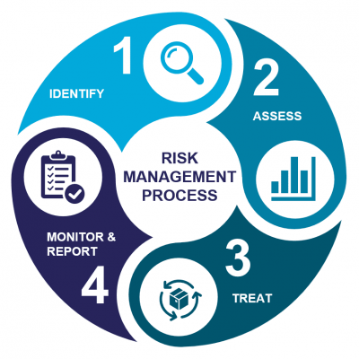**Job Aid: Risk Management Overview** XC 59

Adapted from

[MiGSO-PCUBED](https://www.migso-pcubed.com/blog/risk-management/four-step-risk-management-process/) – The Risk Management Process: 4 Essential Steps

**Mitigate and control the risk.**

* After assessing the risks, develop strategies to mitigate or control them. This step involves identifying and implementing measures to reduce the likelihood and/or severity of risks.
* Risk mitigation strategies can include **risk avoidance, risk transfer, risk reduction, and risk acceptance**.
* Effective risk management involves planning and monitoring these mitigation strategies to ensure they remain effective over time.

**Continuously monitor and review.**

* Regularly assess the status of identified risks to determine if they have evolved or new risks have emerged.
* Regular reviews ensure that the risk management strategies in place are still relevant and effective.
* Adjustments may be made as needed to address changing circumstances and maintain an optimal level of risk control.

**Evaluate the likelihood of each risk occurring and the potential impact it could have**.

* prioritize risks based on their potential impact. This allows you to focus on managing the most critical ones.
* Common techniques used in this step include risk matrices, qualitative and quantitative analysis, and probability-impact assessments.

**Identify, document, and categorize risks.**

* Undertake a systematic process of identifying risks using tools and techniques such as:
  + Process Mapping
  + Audits
  + Non-Conformity Reporting
  + Brainstorming sessions,
  + Data analysis.
* Document each identified risk, describing its nature, causes, and potential consequences.
* Categorize risks into different types, such as financial, operational, strategic, or compliance related.